**Exercises**

**A.** Fill in the blanks with the correct form of **this** / **that**/ **these** / **those**, and the correct form of verb BE (**is / are**)

1. __________is ______this______________ an old car. Resultado de imagen para a hand pointing picture 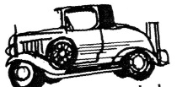
2. ________________those are _________ boots. Resultado de imagen para a hand pointing picture ……………………….………. 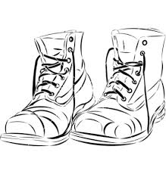
3. __________________this is______________ an apple. Resultado de imagen para a hand pointing picture
4. __________________those__are________ keys. Resultado de imagen para a hand pointing picture……………………………………..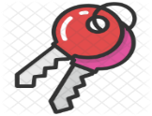

5. _____________that___is______________ a ball. Resultado de imagen para a hand pointing picture …………………………………. 

6. _________these_____are__________________books . Resultado de imagen para a hand pointing picture

**B.** Write questions using: **this** / **that**/ **these** / **those**, and the correct form of verb BE (**is / are**), then give complete answers using the pictures below. Look at the examples.

***Example***: - What is ***that***? - that’s a camera. Resultado de imagen para a hand pointing picture …………………………………. 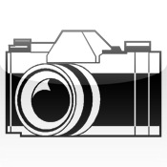

- What are ***these***? – These are students. Resultado de imagen para a hand pointing picture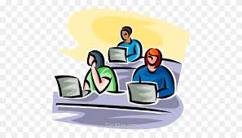

1. What ______is those__________________________? Resultado de imagen para a hand pointing picture …………………. 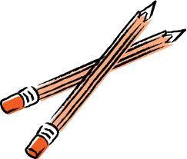

________ those_are __pencils_________________________________.

2. What ___________is that____________________? Resultado de imagen para a hand pointing picture ……………………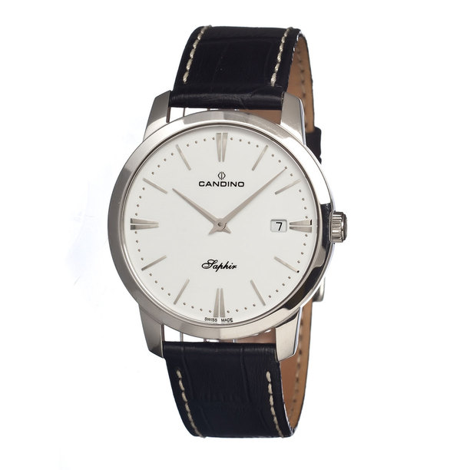

____________this is a _watch______________________________.

3. What __________are___these_______________? Resultado de imagen para a hand pointing picture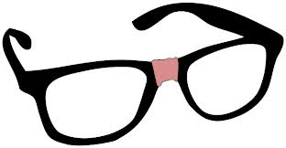

__________they_are__glasess___________________________.

4. What _________are__this____________________________? Resultado de imagen para a hand pointing picture 

____________they are a maps______________________________.

**REMEMBER TO FOLLOW THE EXAMPLES!!!**